ECEn 340-001 - Lab 3

Ben Simpson, Section # 001

Benjamin Bergeson, Section # 001

**Objective**

-Build the laser tag transmitter board

**Overview**

This transmitter board will be used as part of the laser tag system in ECEn 390. It will be part of the interface between the Xilinx board and the laser gun. There are three separate systems on the board. The transmitter module will power an LED based on a low voltage square wave input. The hit indicator module will power an LED based on an intermittent low-voltage input. The trigger module will create a voltage when the trigger is pulled.

**Transmitter**

We designed our transmitter circuit based on the design in the lab. The current going through the diode should be 100 mA. We calculated an approximate value of the resistor Rb to be 7.5 kΩ. Our calculations are shown in Figure 1.

Insert Calculations

We designed the circuit in LTSpice (Figure 2) and ran a simulation. We discovered that Rb had too much resistance. We adjusted the value of the resistor until we achieved the correct current through the diode. Our final resistor value is 6 kΩ. Our final simulation is shown in Figure 3. 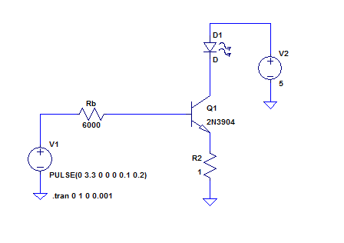

Figure 2. Transmitter Circuit

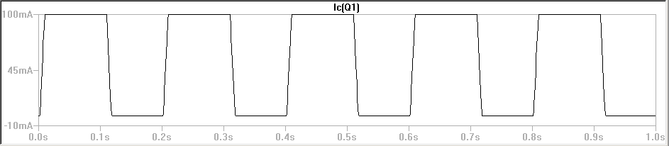

Figure 3. Simulation result. The voltage is measured across R2. A value of 1 V indicates a current of approximately 100 mA through D1, our LED.

We wired up our circuit and found that the 6.8 kΩ resistor for Rb yielded the best results. We were able to obtain a waveform for the voltage across the series resistor. We then divide the voltage by the resistance, which is 1 Ω and obtain the IE. The waveform can be seen in figure 4. Input 1 is the voltage across the series resistor and input 2 is the function generator.

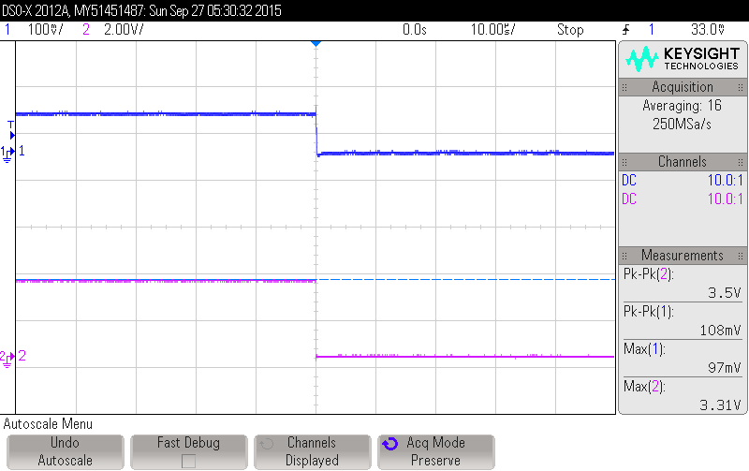

Figure 4 Waveform of voltage across the series resistor

So the resistor that we will use in our transmitter board for the transmitter portion will be a 6.8 kΩ resistor, following the schematic shown in figure 2.

**Hit Indicator**

We designed our hit indicator circuit based off the schematic from the transmitter. After crunching some numbers (calculations shown in figure 5), we arrived at the answer. We calculated that Rb should be 38153 Ω.

Insert Calculations

The schematic that we designed in LTSpice can be seen in figure 6. We then simulated the circuit using the answer that we calculated above. The simulation waveform can be seen in figure 7 below.

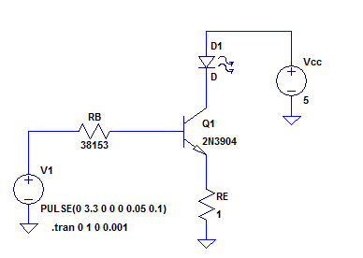

Figure 6 LTSpice schematic for hit indicator

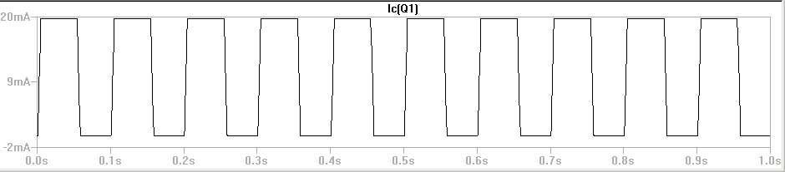

Figure 7 LTSpice simulation for hit indicator

We wired up our circuit on the breadboard according to our schematic. At first we used a 39 kΩ resistor and we got a voltage drop across the series resistor of around 22 mV. We then tried a 47 kΩ resistor and got even closer. The waveform when we used the 47 kΩ resistor can be seen below in figure 8. Input 1 is the input from the function generator. Input 2 is the voltage drop across the 1 Ω series resistor.

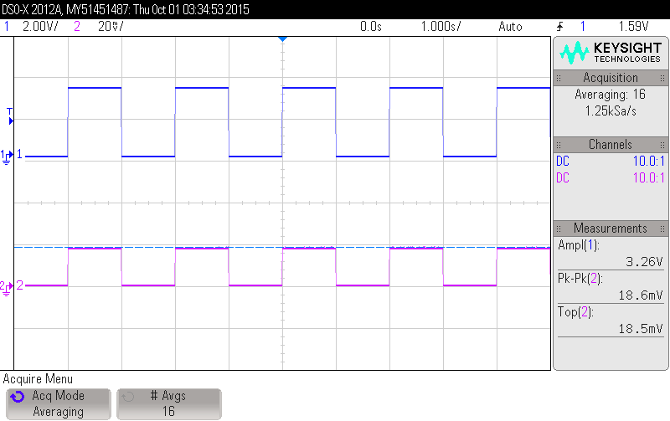

Figure 8 Oscilloscope waveform for hit indicator circuit

**Trigger**

Basically we just need the circuit for the trigger to be a voltage divider. We put two resistor in series and calculated the ratio between them needed to drop a 5 V input to a 3.3 V output. Our calculations can be seen below in figure 9.

Insert Calculations

From our calculation we were able to see that Ra would be roughly half of Rb. We decided to use a 1.2 kΩ resistor for Ra and a 2.2 kΩ resistor for Rb based on the resistors we had available to us. We designed a schematic in LTSpice using those values. The schematic and the corresponding simulation can be seen in figures 10 and 11 respectively.

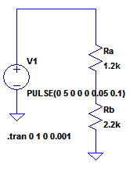

Figure 10 LTSpice schematic for trigger

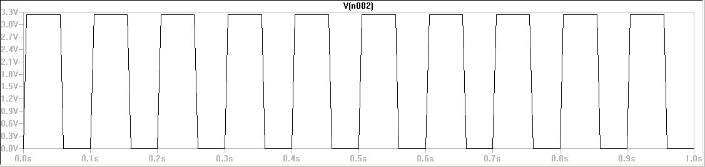

Figure 11 LTSpice simulation for trigger circuit

We built the circuit on the breadboard and used a 0 to 5 V square wave from the function generator to test the output. The waveform from the oscilloscope can be seen below in figure 12. Input 1 is the input from the function generator. Input 2 is the output coming from between the resistors.

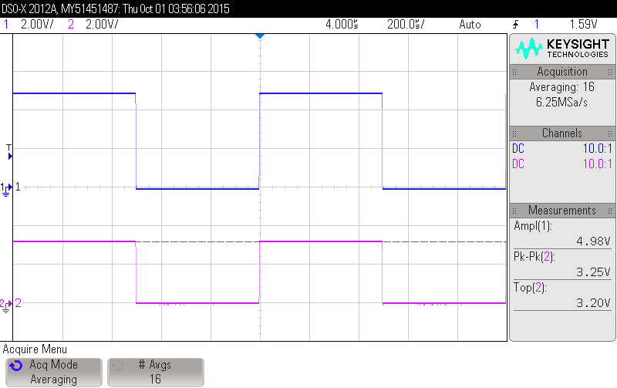

Figure 12 Oscilliscope waveform for trigger circuit

**Final Board**

**Conclusion**